**HOPPING FROG**

EGR 598: Foldable-Robotics

Spring 2018

**Bhat, Sandesh G. Carlson, Andrew Uyehara, Brandon**

# Introduction:

Robotic systems have had a hard time mimicking the biomechanical system present in animals. This project aims at modelling and recreating such a system: the hopping of a frog. The project will focus on building a robot capable of jumping without any external impetus as well as sensing its own pose in the environment. The concept of foldable robotics will play a major role in the design of the device. This robotic device will have multiple application, but the project’s domain of operation will include the device jumping in only one direction.

The plan created for the project includes the modelling of the system, design workflow, manufacturing, and experimentation. The results from the experiments will be compared to the actual biological system (aka. The frog) and the design and model will be reiterated to improve the device’s performance. All these will be discussed below, and each prototype’s objective will be explained.

# Background:

The device was inspired by frogs. The ability to jump and travel efficiently in their environment is present in most species of frogs. To understand the biomechanics involved in the jumping motion of the frog, multiple online and journal references were used. Figure 1 shows the frog hind leg with a very crude approximation of its dynamics [1]. It was also found out that a frog that weighs 20g would expend 50 J/kg-m in respiration power. This frog would be capable of jumping about 20 times its body length in 0.15 seconds [2].

Many researchers have studied frogs and the behavior of their muscles while jumping. Some of them attempted to create a robot capable of mimicking the motion. Some of these research articles were referred to get a good understanding of what the robotic device would mimic [2-8]. There also have been many passive systems that mimic the

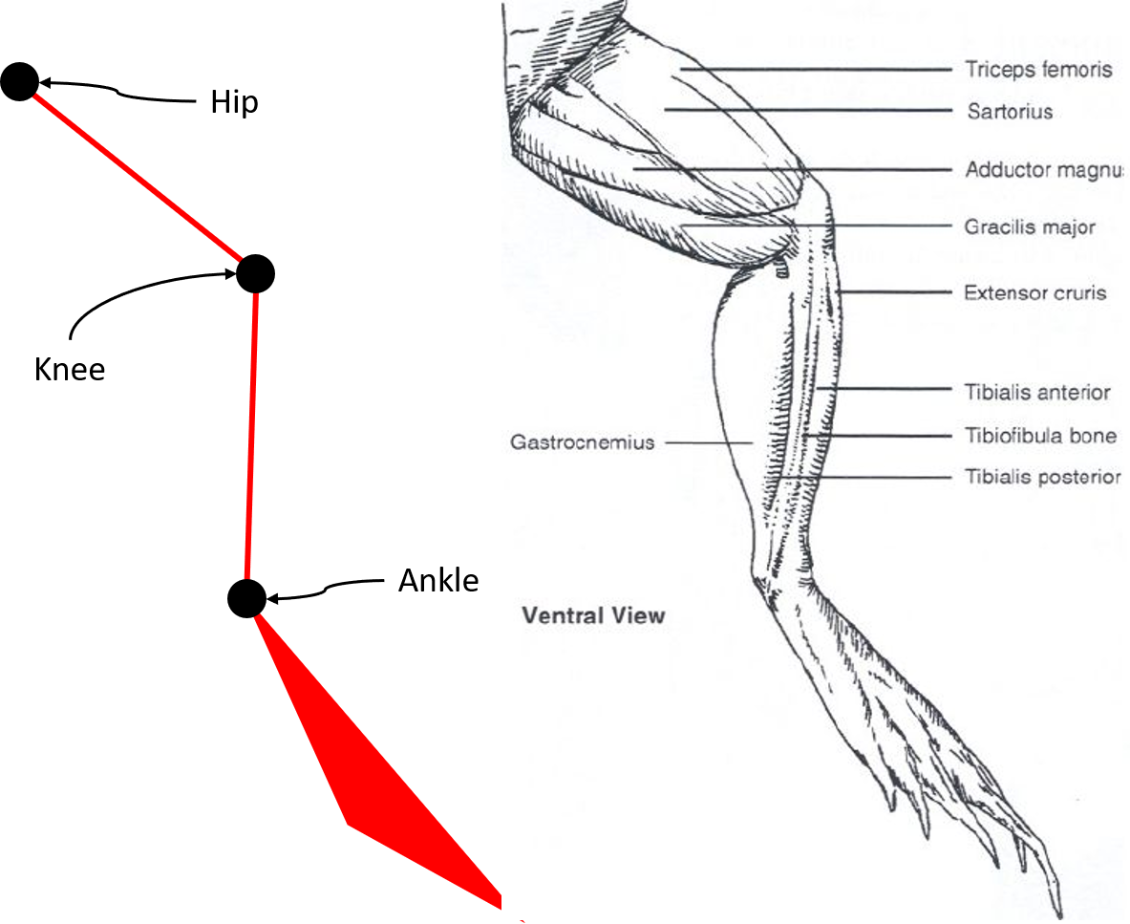

**FIGURE 1. MUSCULAR STRUCTURE OF THE FROG HIND LEG [1]**

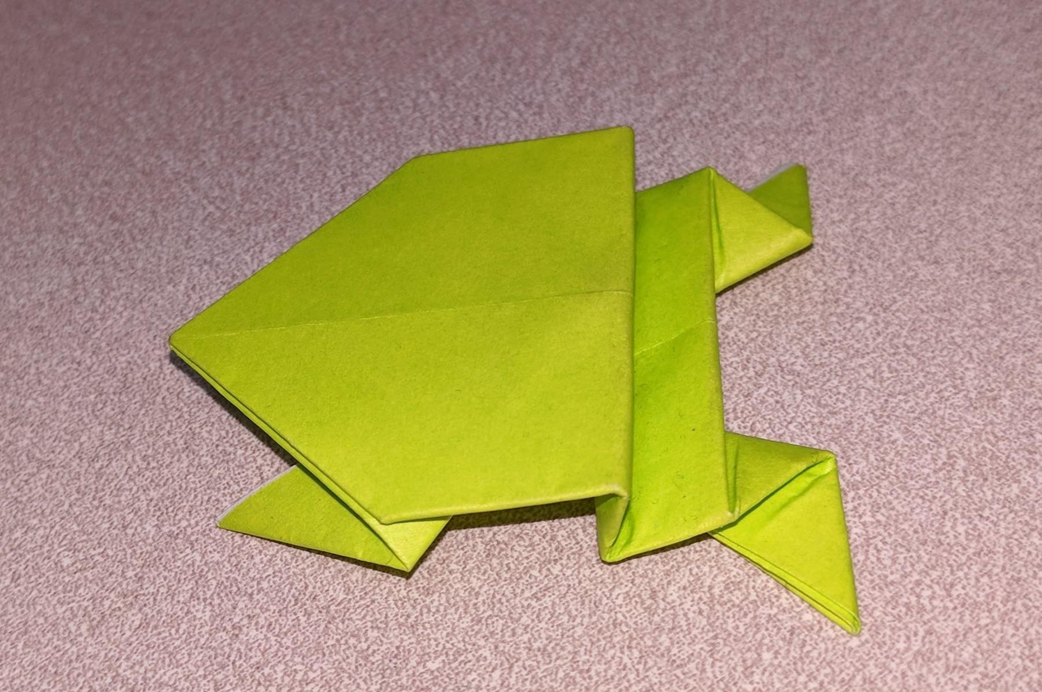

**FIGURE 2. FROG INSPIRED PASSIVE ORIGAMI JUMPING MECHANISM**

# Goals:

The primary goal of the project was to create a robot using the principles of foldable robotics that could hop from one point to the other. The robot’s body would consist of laminated, foldable structures that would be actuated/ moved using motors. The robot would be initially designed to hop twice its height in the vertical direction and twice its length in the horizontal direction. The robot would be able to contain its own components on its back and would not need any harness to support its own weight.

# Design:

The design of the robot was initiated by developing a design for the hind limbs of the robot. The design of the hind limbs was iterated after trying paper cut outs of various prototypes with different angles and the one with the best range of motion was selected. To model the hind legs, a python scripts was created as in Appendix A. The script studied the motion of the hind leg as the device underwent the jumping motion. The initial pose of the hind leg was as in Figure 2. This pose was changed from 90 degrees to 140 degrees. The progression of the leg was as shown in Figure 3. The code also plotted the output points of the hind leg (displayed in black). The main design variable was the angle of the folds. The initial design consisted of a 45 degrees fold angle, which was later changed to 70 degrees. Other variables considered and changed during the numerous iterations were the limb lengths and the overall width of the robot body. The robot’s body width was not included in the model. The data from the simulated model was used to calculate the forces needed at the output point by using the Jacobian matrix. The Jacobian matrix (J) can be summarized to the equation below:

$$J = \left[\begin{matrix}\frac{∂f}{∂x_{1}} & … & \frac{∂f}{∂x_{n}}\end{matrix}\right]=\left[\begin{matrix}\frac{∂f_{1}}{∂x_{1}} & ⋯ & \frac{∂ f_{1}}{∂ x_{n}} \\ ⋮ & ⋱ & ⋮ \\ \frac{∂ f_{n}}{∂ x_{1}} & ⋯ & \frac{∂ f_{n}}{∂ x_{n}}\end{matrix}\right]$$

where $f_{1},….$ were the output forces and $x_{1}, ….$ were the input parameters. The desired output forces were obtained from the goal of the project. The required power was found using the following expression:

$$P_{\left(max. required\right) }=\frac{K.x_{\left(max\right)}^{2}}{2}$$

After the required power ($P_{\left(max. required\right) }$) was calculated, a motor was selected and modelled to be able to stretch the springs. The behavior of this model at maximum efficiency was calculated and it was compared to the requirement of the device. This process had to be repeated a few times before the right motor was selected.

The selected motor was a Micro Metal Gearmotor with a gear ratio of 298:1. It was controlled using a Pro-Trinket microcontroller. This motor was actuated when a certain signal was received from the onboard sensors. This sensor was an Inertial Measurement Unit (IMU) BNO055. The sensor was used to measure the position of the device along with the accelerations, which in turn actuated the motor. The Pro-trinket was programmed to actuate the motor when the device was stationary, to prevent actuation when the device was mid-air. All these components were powered using a 3.5 V onboard battery which was connected to a voltage regulator to convert the input to 5V. Hence, the device was self-sufficient and needed no outer power supply.

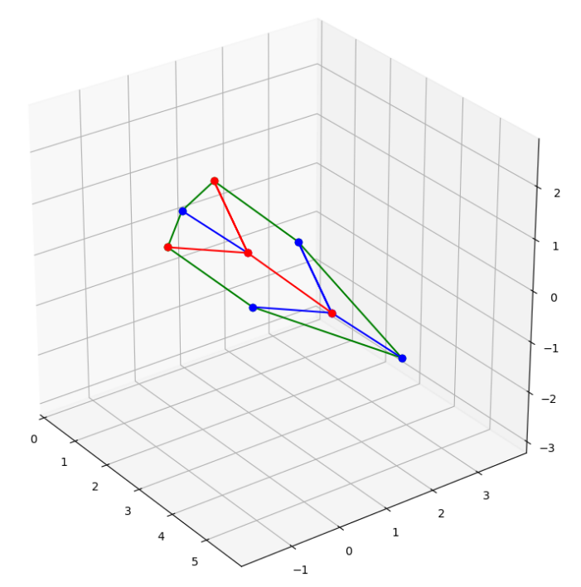

**FIGURE 3. INITIAL POSE OF THE HIND LEG AS PLOTTED IN PYTHON**

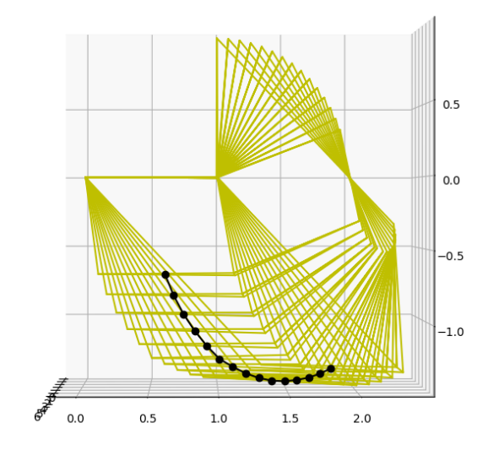

**FIGURE 4. HIND LEG ACTUATION WITH THE OUTPUT POINT IN BLACK**

# Manufacturing:

The robot was manufactured using the process of lamination. This process requires a flexible layer sandwiched between two stiff material layers creating a five-layer laminate. The stiff materials are cut in a specific way as to allow the flexible layer fold and the mechanism to move in the manner intended. Each laminate layer is laser cut separately and then combined to form the laminate. Figure 5 shows the cut-out image of the lamination process. The hinge width was decided after the materials were selected. The materials used for the manufacturing of the prototype were as follows:

|  |  |  |  |
| --- | --- | --- | --- |
| **Layer** | **Material** | **Thickness** | **Weight** |
| One, Five | Cardboard | .02 inch | 7.2g |
| Two, Four | Adhesive | .0005 inch | 2.3g |
| Three | Acetate | .002 inch | 4.6g |

The above materials were selected based on their light-weight, easy manufacturability, and quick prototyping capabilities. For the proposed design, a castellated hinge of width 2 mm was selected and incorporated in the design.

The mechanism also included two 3D printed layers. These were used to reinforce the laminate layers and drive the mechanism using a motor. These 3D prints were kept light by using a 10% infill and 1 mm top and bottom layer width. The laminate was designed to allow the top and bottom 3D printed parts to move parallel to each other using something known as the ‘Sarrus Linkage’. The Sarrus Linkage prevents any lateral movement between the top and bottom layers and ensures no loss in power occurs due to any lateral movement.

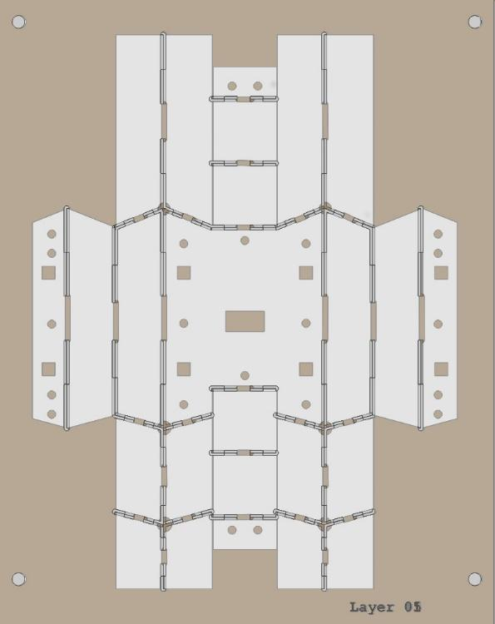

**FIGURE 5. CUT FILE FOR THE LAMINATE MECHANISM OF THE ROBOT.**

The laminates were secured to the 3D printed top and bottom plates with plastic pop-rivets. The mechanism was moved using a motor and spring assembly. The motor pulled apart the top layer and the bottom layer while the springs (rubber bands) resisted this motion. The force and power delivered by the rubber bands was the main actuation used to make the device jump. These rubber bands were characterized as follows:

A 100-gram weight was hung from the one of the rubber bands. This was used as a starting value. Then a 200-gram weight was hung from the rubber band. The difference in force exerted on the rubber band was compared to the difference in the length of the stretched rubber band. This was used in the formula $F = k*x$. The starting stretch of the rubber band was 22 millimeters and it was stretched to 30 millimeters for a difference of 8 millimeters. The difference in mass was 100 grams which came out to .9807 Newtons. Thus, the spring constant was calculated to be 122.6 N/m. In the proposed device the cam stretched the rubber bands 34.21 millimeters for roughly 4.194 Newtons of force per rubber band.

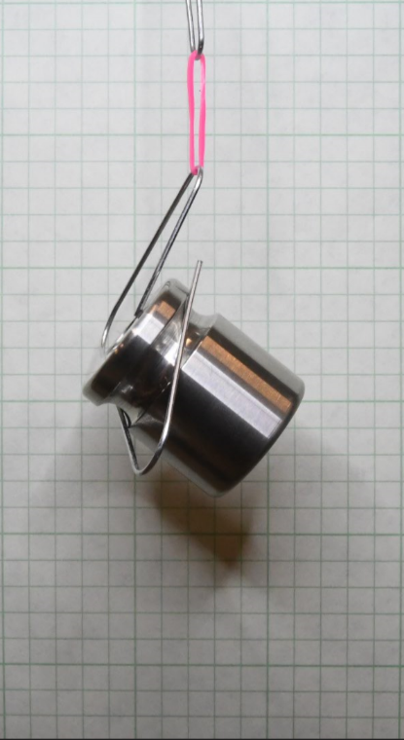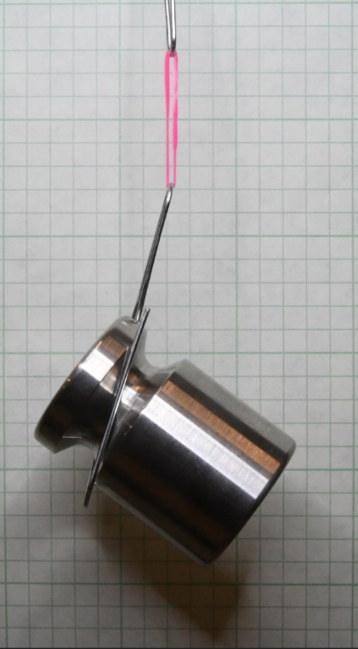

**FIGURE 6. 100G AND 200G WEIGHTS HUNG WITH A 5MM SCALE BACKGROUND**

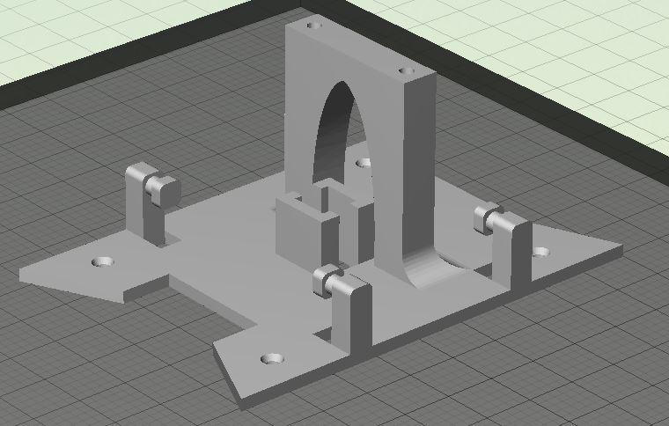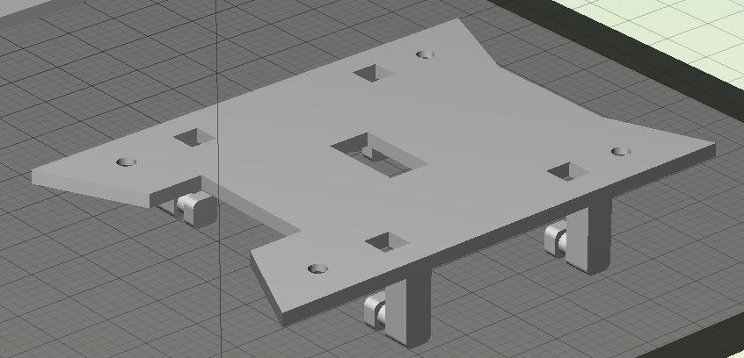

**FIGURE 7. TOP AND BOTTOM MOUNTING PLATES**

# Experiments:

Multiple experiments were performed on the device. The goal of these experiments was to compare the behavior of the robotic device to the biological system and develop the system further to improve its response. This allowed the fine tuning of the model parameters. The previous iterations were unsuccessful in jumping so some design parameters were changed, and a new design was manufactured. The following experiments were performed on the current design:

## Ground Reaction Force Measurement:

Ground reaction force on the hind legs of the device were measured to compare the device with the biological system. The experimental setup consisted of a force plate calibrated for low force measurements. The force plate used for the experiment measured the force only in the vertical direction. The setup is as shown in Figure 7. The device was made to jump from the force plate and the GRF data during the launch was noted. This experiment was repeated three times and results from each run were recorded and averaged to get a general curve of GRF over the launch period.

## Internal Acceleration Measurement:

This experiment was designed to measure the acceleration of the device during its jumping phase. To measure this acceleration, an Inertial Measurement Unit (IMU) device was placed on the device. This IMU measured the acceleration of the robotic device throughout its operation and it was also used as a position tracking sensor. The results from this experiment were used to determine the amount of inertial forces the device undergoes and to understand its effect on the dynamics of the robotic device. Figure 8 shows the setup of the IMU on the robot. The IMU was mounted on to the 3D printed parts to for better wire management.

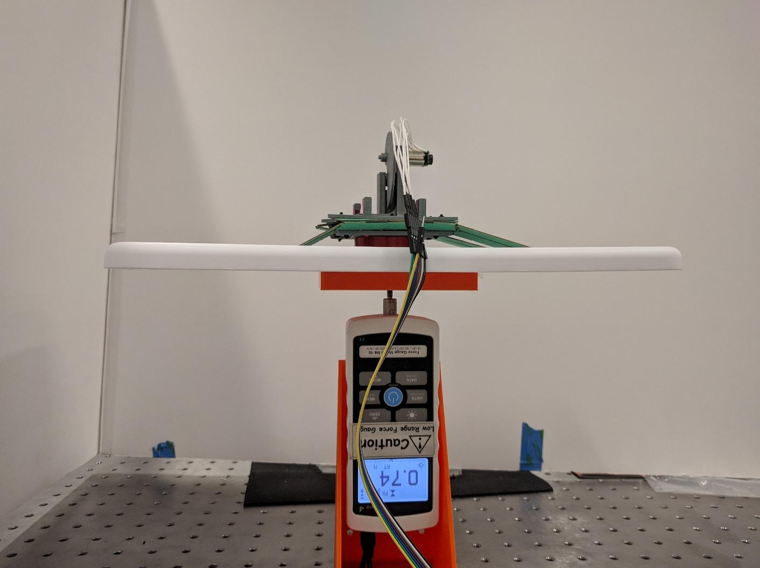

**FIGURE 8. FORCE PLATE EXPERIMENTAL SETUP**

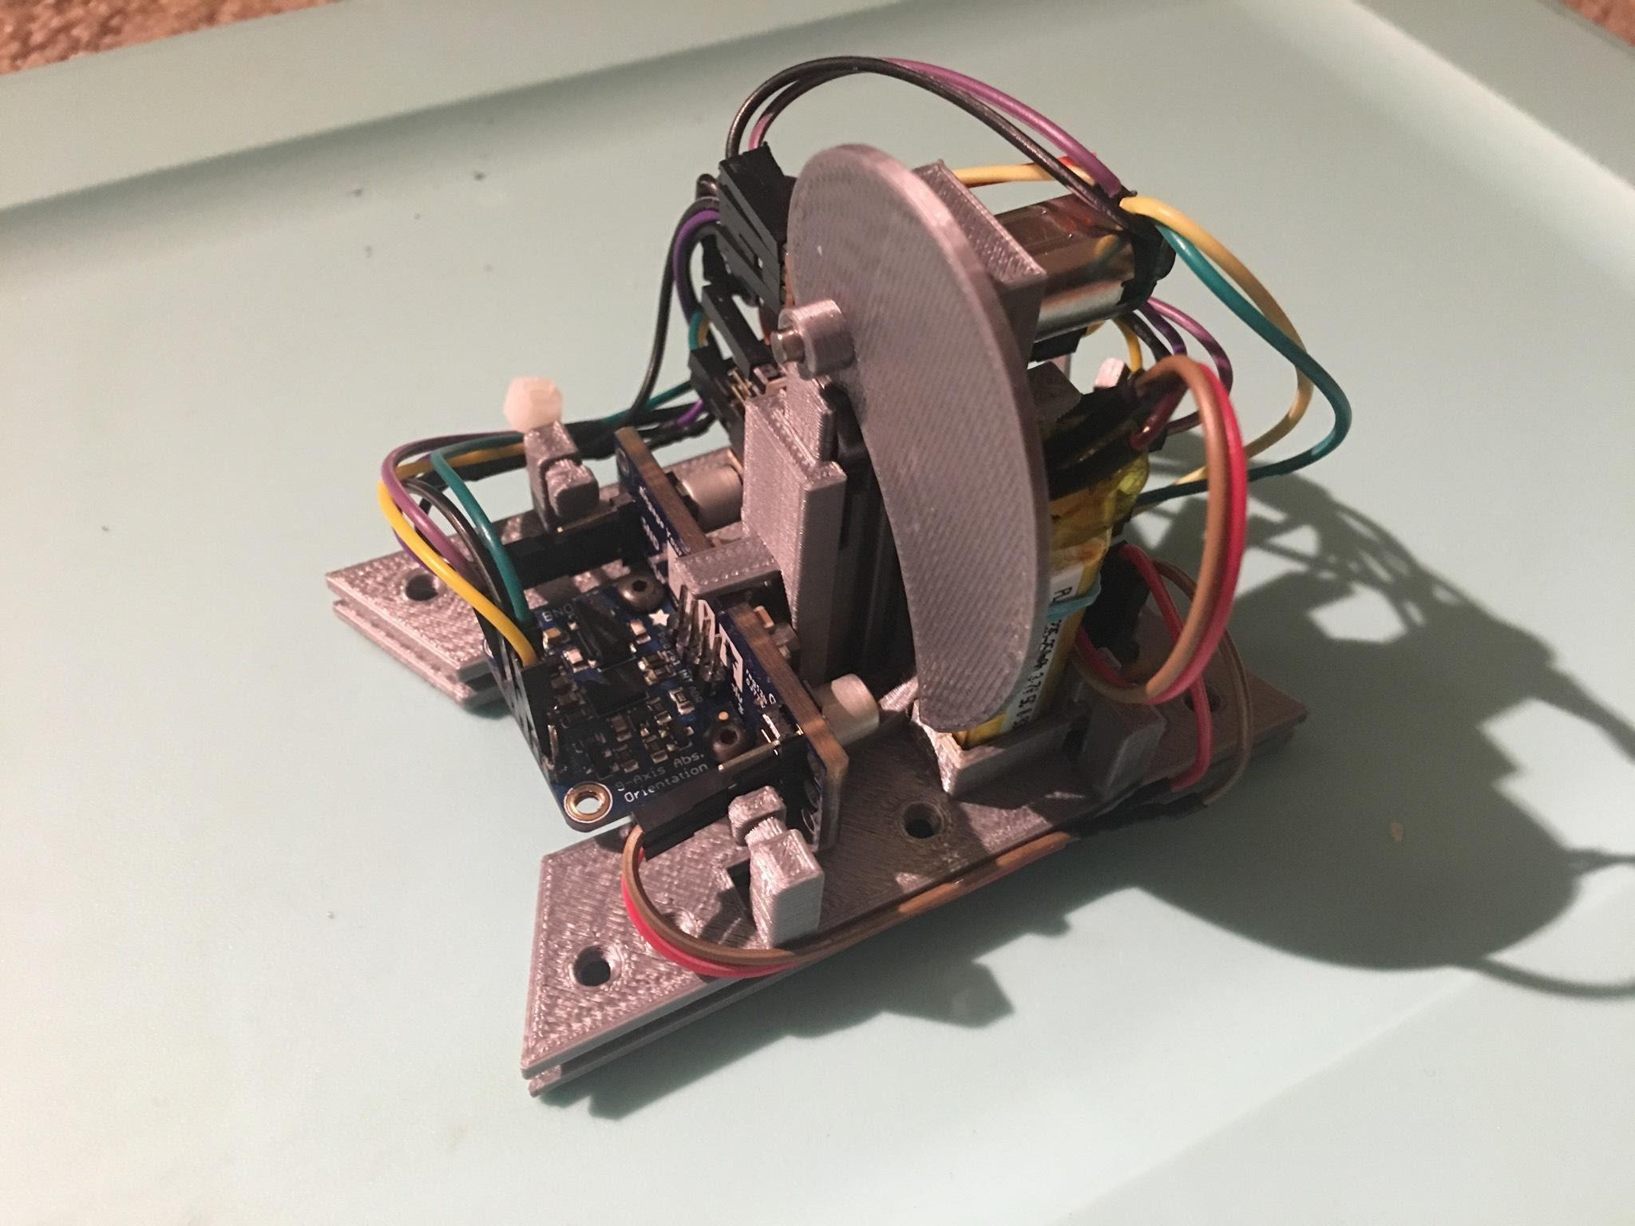

**FIGURE 9. IMU ON THE ROBOT’S 3D PRINTED PLATES**

# Results and Discussions:

## Ground Reaction Force Measurement:

The experiment was repeated three times and the data was captured. The plot in Figure 9 shows the three test runs plotted together. Due to the set amount of delay in the code, all the three tests have the jump fluctuations at around the same time. The test rig was a temporary contraption and was a bit wobbly. Hence after the initial jump, the robot did not land on the platform properly. Figure 10 shows the single jump GRF data for the three tests. The plots follow the same general trend. There is a small dip in the GRF before the jump and the GRF can be seen to shoot rapidly just before the jump. The plot would have been clearer given a better force gauge with a better sampling time. But, this plot was considered sufficient for current purposes.



**FIGURE 10. GRF OUTPUT FOR 3 TEST RUNS**



**FIGURE 11. GRF FLUCTUATIONS DURING A JUMP**

## Internal Acceleration Measurement:

The major purpose of the IMU was to provide internal system acceleration of the robot. It was also used to acquire the position of the robot in 3D space. Figure 11 shows the X, Y, Z position of the robot. Though the IMU output was noisy, the jump instance can be clearly seen. As seen in the experiment, the robot did not jump too high. Figure 12 shows the acceleration of the robot. The robot achieved a peak acceleration of 1.5 m/s2. This can also be attributed to the noise in the sensor. Hence, further testing needs to be done.

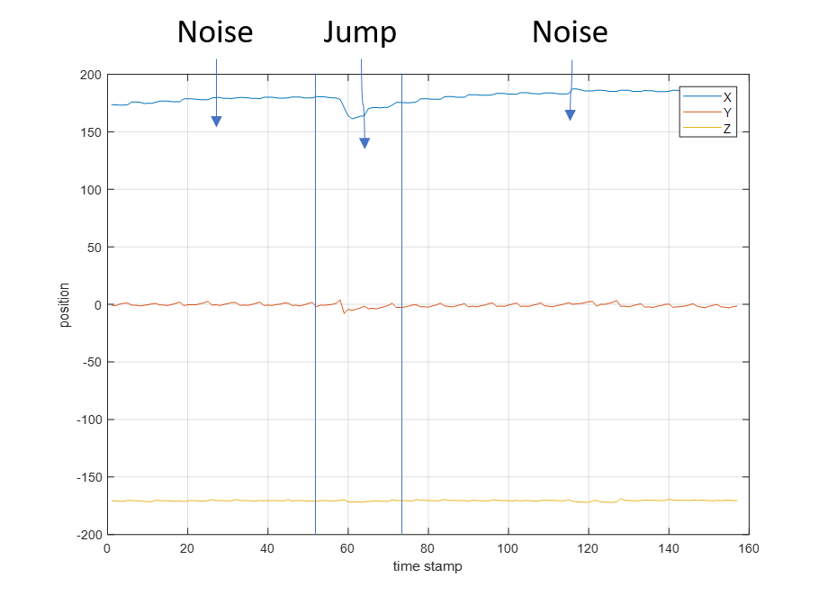

**FIGURE 12. IMU POSITION OUTPUT FOR THE ROBOT DURING A JUMP**

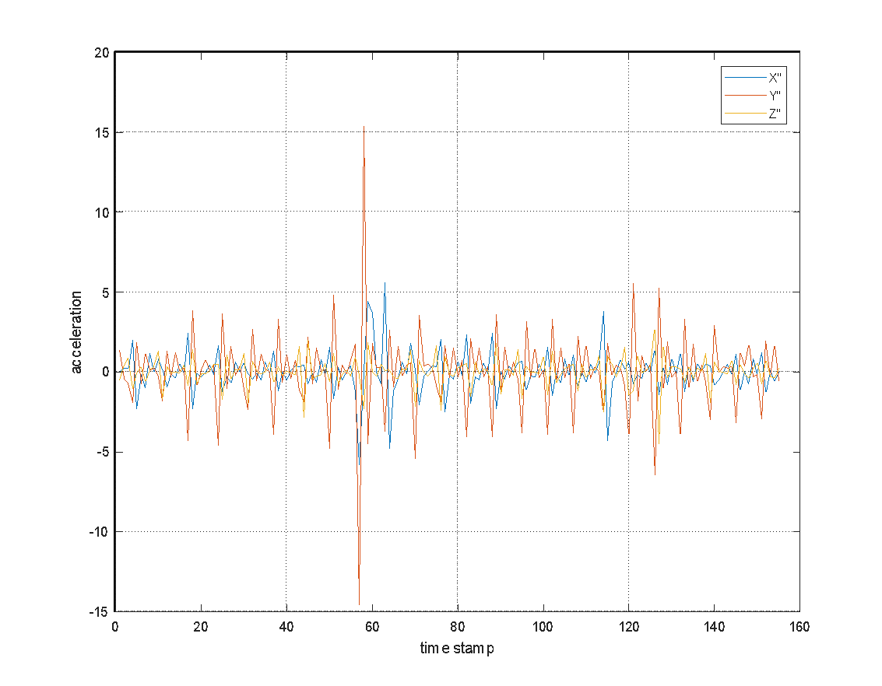

**FIGURE 13. IMU ACCELERATION OUTPUT**

The robot performed below expectations. The initial goal was to make the robot hop twice its length and twice its height. But during the experiments, the current design could only hop a couple of millimeters. The major reason for this was the weight of the robot causing the limbs to go into singularity and then flipping the other way. Also, the dynamics modelled in python did not match the actual dynamics of the robot. The better way of making the robot jump would be to open the mechanism as fast as possible. This could be achieved using compressive springs and a motor used to compress them. The current design did not allow for a modular experience where the components and laminates could be switched for easier testing. Such a laminate device could be tested quickly and over a wide region of variables.

# Conclusion and Future Improvements:

The current design under-performed and a way to fix this was figured out. The robot went into singularity after landing. In future designs, this can be fixed by adding a spring (rubber band) to snap the limbs back into the preferred position. Also, a stiffer laminate will be used to ensure no bending in the laminate. The tests performed on the current design provided results that were satisfactory and proved that the tests were an effective way of verifying the design and its effectiveness. In the future better testing equipment will be used to obtain more accurate results and the design will be changed to include better singularity preventions. The design will also include an inter-changeable leg design to facilitate better testing. Multiple limb designs will be tried to understand the behavior of limb design on the robot’s response.

# References

[1]http://animalia-life.club/openphoto.php?img=http://bio1903.nicerweb.com/doc/class/bio1151/Locked/media/lab/animalia/muscles/img/Fig9.jpg

[2] Moo, E. K., Peterson, D. R., Leonard, T. R., Kaya, M., & Herzog, W. (2017). In vivo muscle force and muscle power during near-maximal frog jumps. *PloS one*, *12*(3), e0173415.

[3] Jeongdo Ahn, Jongwon Park, Kyung-Soo Kim, & Soohyun Kim. (2013). Frog-inspired jumping robot for overcoming high obstacles. 2013 44th International Symposium on Robotics. (ISR), 1-4

[4] Jianjun, Y., Xiangquan, T., & Shenghai, H. (2013). Structural design of a frog-like hopping robot with consideration of vibration and its kinematic analysis. Journal of Vibration and Control, 19(2), 309-320

[5] Moo, Eng Kuan & R. Peterson, Daniel & R. Leonard, Timothy & Kaya, Motoshi & Herzog, Walter. (2017). In vivo muscle force and muscle power during near-maximal frog jumps. PLOS ONE. 12. e0173415. 10.1371/journal.pone.0173415.

[6] Reddy, N., Ray, R., & Shome, S. (2011). Modeling and simulation of a jumping frog robot. Mechatronics and Automation (ICMA), 2011 International Conference on, 1264-1268.

[7] Sandra Nauwelaerts, Peter Aerts. (2006). Take-off and landing forces in jumping frogs. Journal of Experimental Biology 2006 209: 66-77; doi: 10.1242/jeb.01969

[8] Thanhtam Ho, & Sangyoon Lee. (2010). Design and implementation of an SMA-actuated jumping robot. Intelligent Robots and Systems (IROS), 2010 IEEE/RSJ International Conference on, 3530-3535.

# Appendix

## Jupyter Device Model Code

https://gist.github.com/mrsandeshbhat/6d6637aa7c5d2fa27d36f784f18608f2

## B. Prototype I

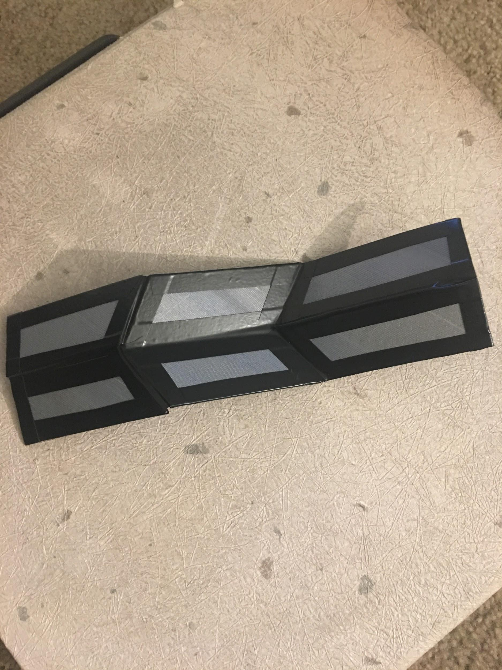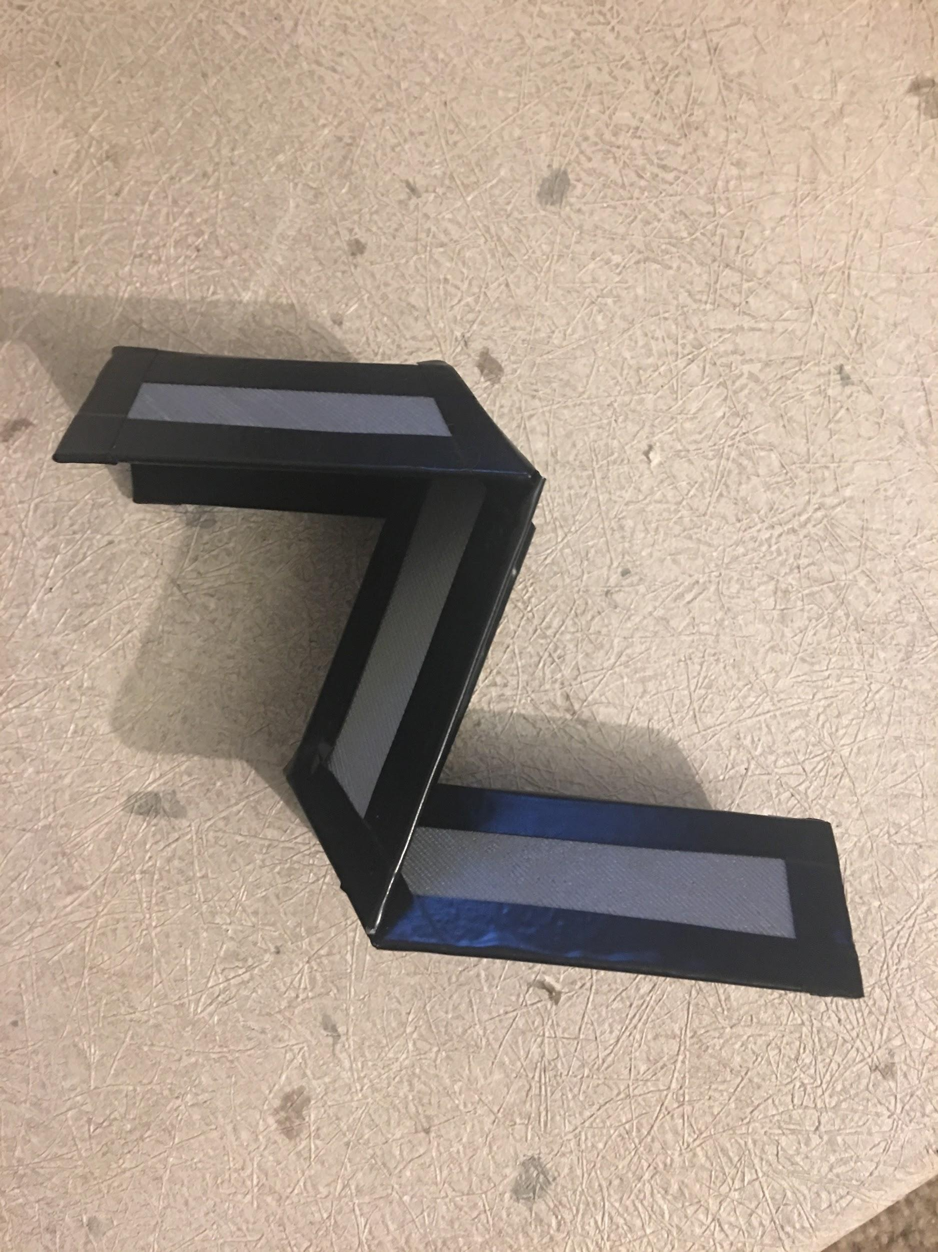

The first initial prototype was of a single leg. Its purpose was to demonstrate the translation of how folding an initial angle in and out the leg is able to achieve extension. This extension would be the driving force which would eventually propel our device forward and off the ground. From creating this prototype, we were able to see how important having the correct joint angles would be to give us the proper movement which would be required. This gave us the inspiration to reproduce this same folding mechanism across all four of our frog’s legs.

## C. Prototype II

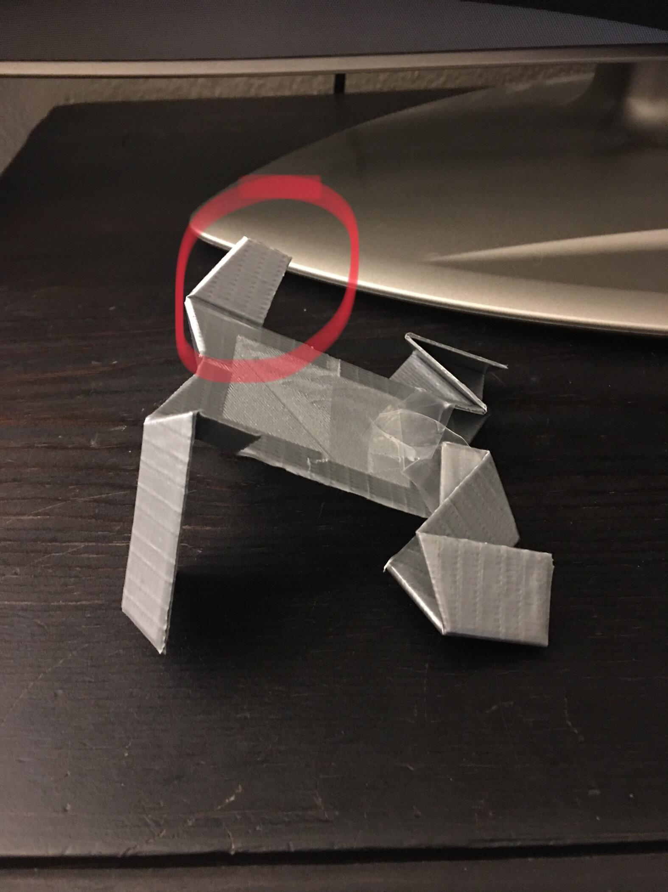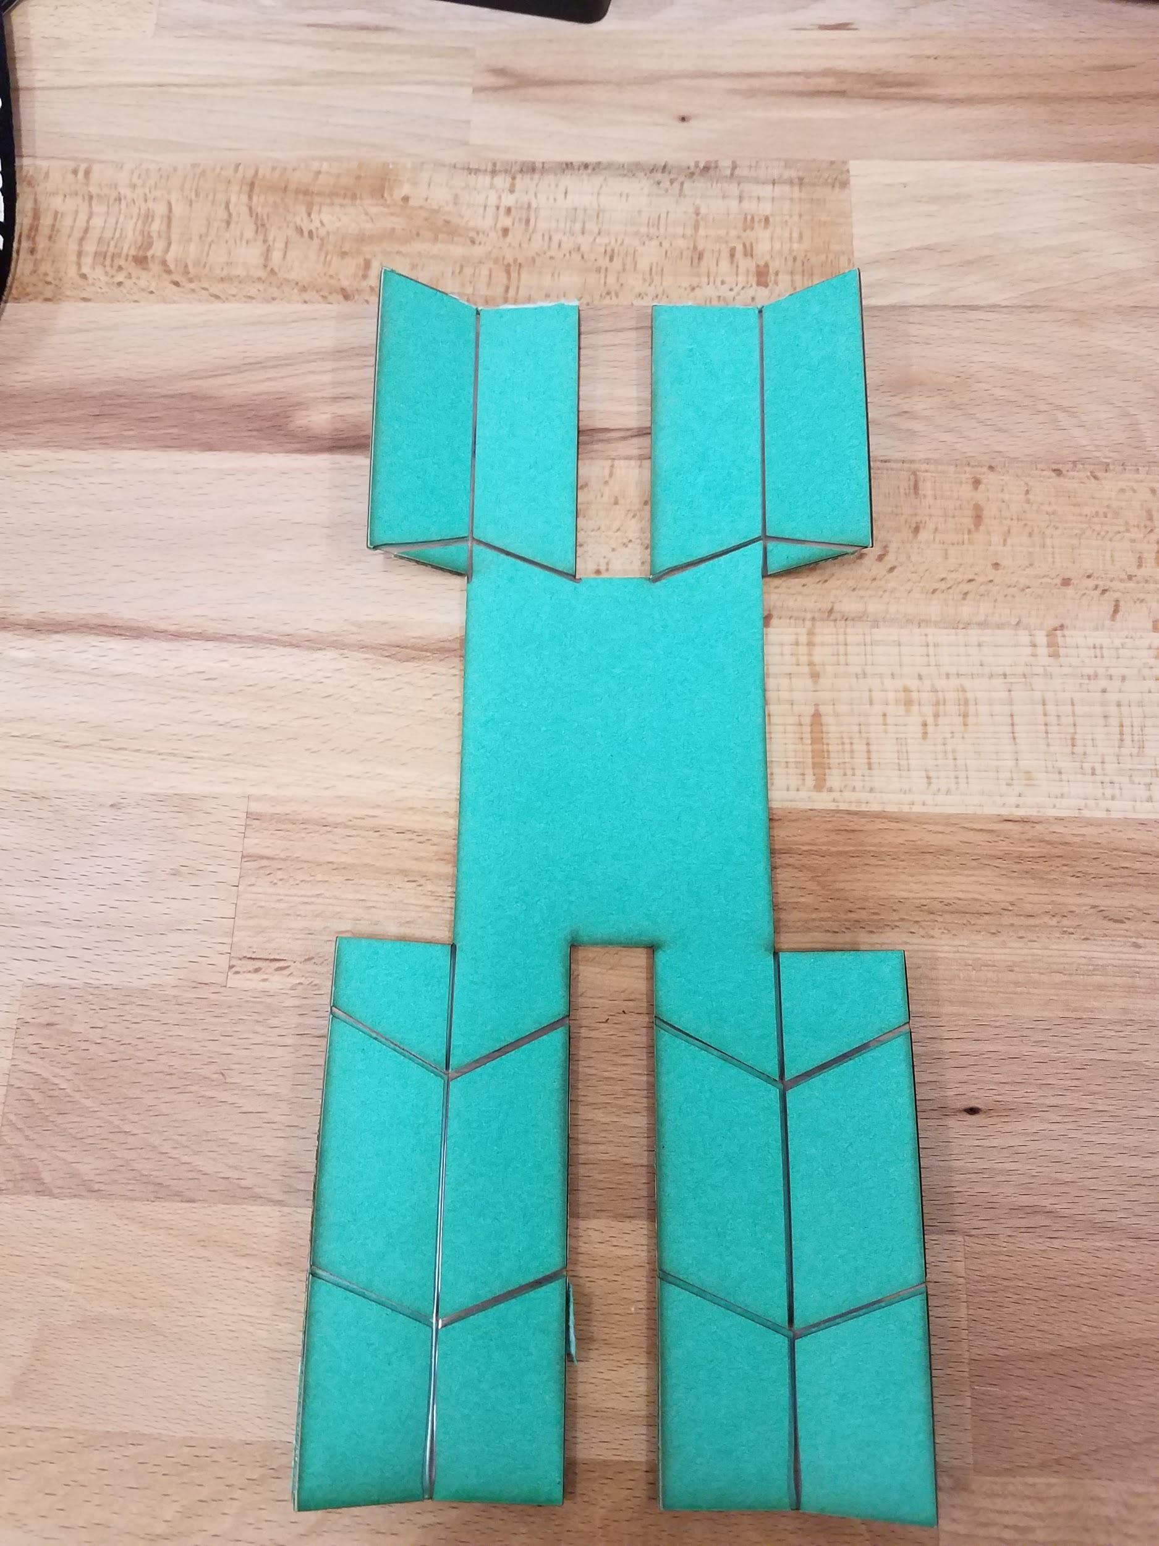

The second prototype was where our frog began to take shape and resemble a similar shape to what we know to be a frog. The initial construction was made from 3D printed links and duct tape because those were the manufacturing processes that were easily available at the time, and it soon followed by a laminate version of the prototype. It incorporated four legs which were all made of joints which needed to be open and close to give it motion to angle itself upward into a given launch angle as well as propel itself forward. The problem with this design is that all four leg joints would have to be precisely controlled and synchronized to achieve the task of jumping. This problem led us to try to achieve a mechanism to control all four legs simultaneously.

## D. Prototype III

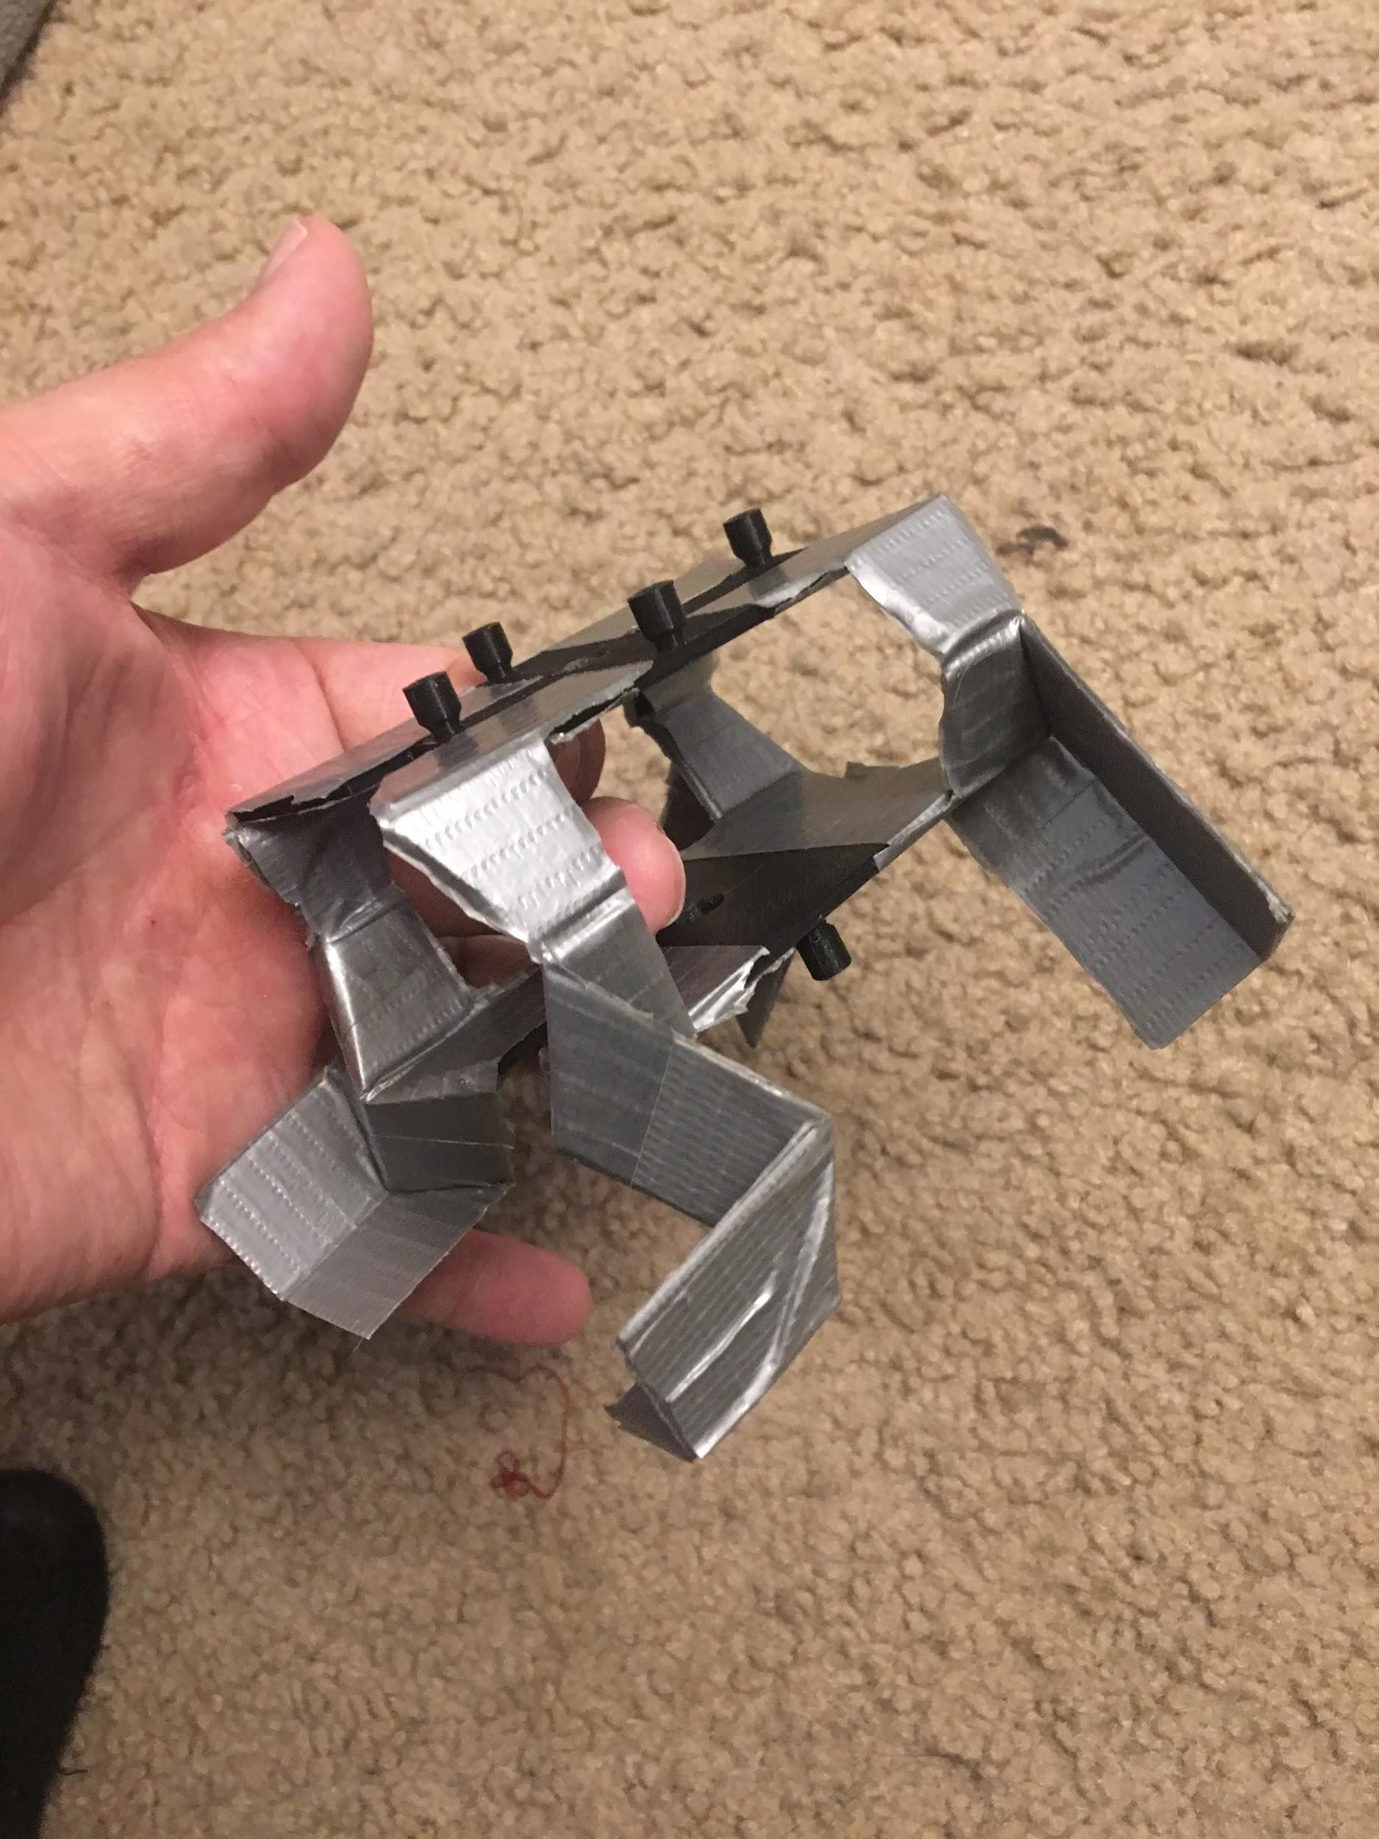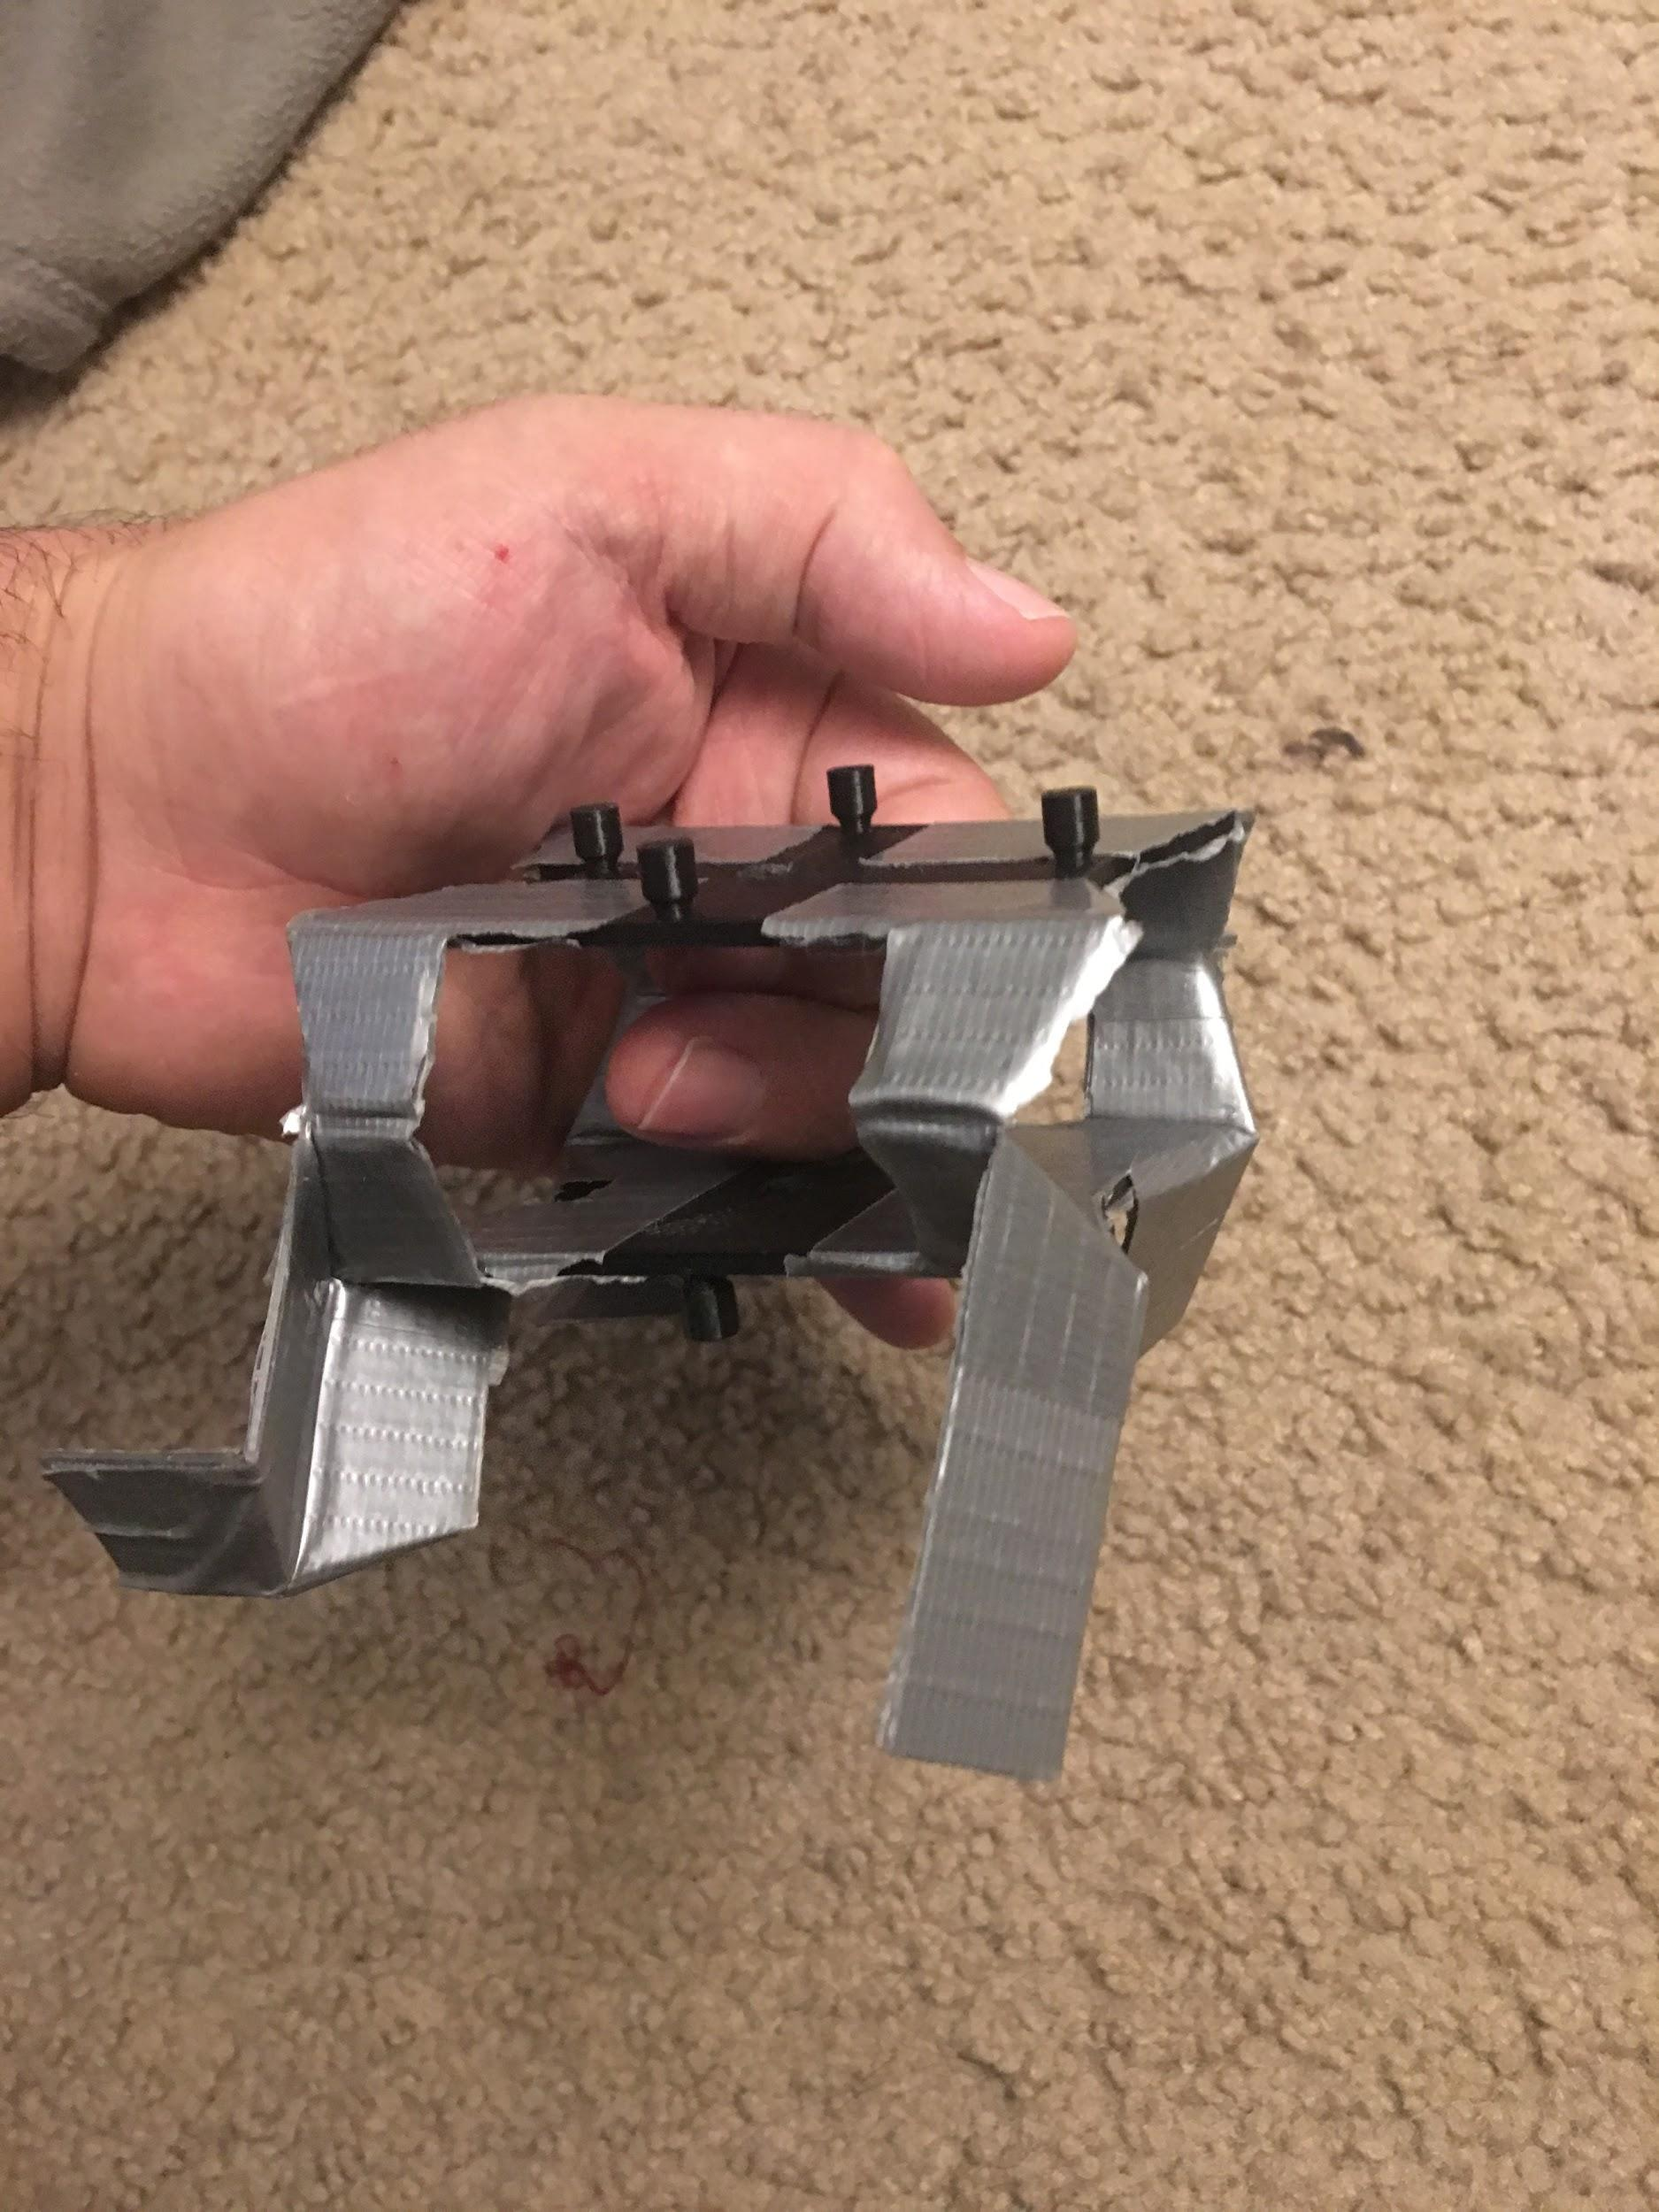

Once again using 3D printed materials which were held together with duct tape we fabricated our third prototype. This design added an additional top plate which mirrored the bottom plate with spring which would draw the two plates together to allow for synchronous movement of all four legs with a fast-acting force. A couple of problems arose from making this design. The top plate was able to move in a shear manner which allowed the legs to move at different rates. This was not only due to the poor materials this prototype was constructed from, but also from the design of the mechanism not being fully constrained. Another issue was the thought in how the mechanism would spread the top and bottom plates apart and then allow them to snap shut instantly. Keeping the weight down would be a factor and so this led to having to design a mechanism which would only use one motor that would be able to have a quick disconnect to allow for the fast-acting force required to jump.

## E. Prototype IV

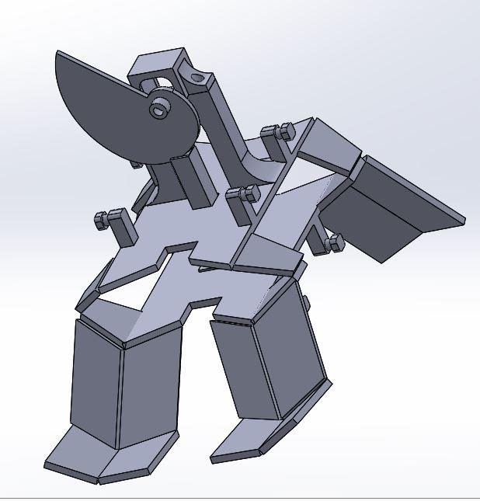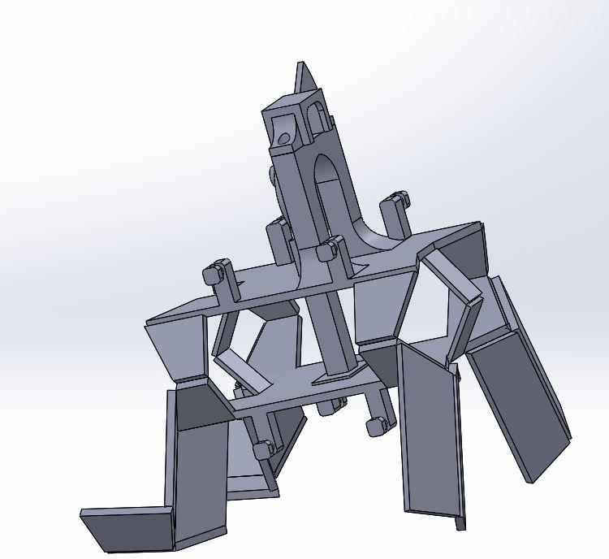

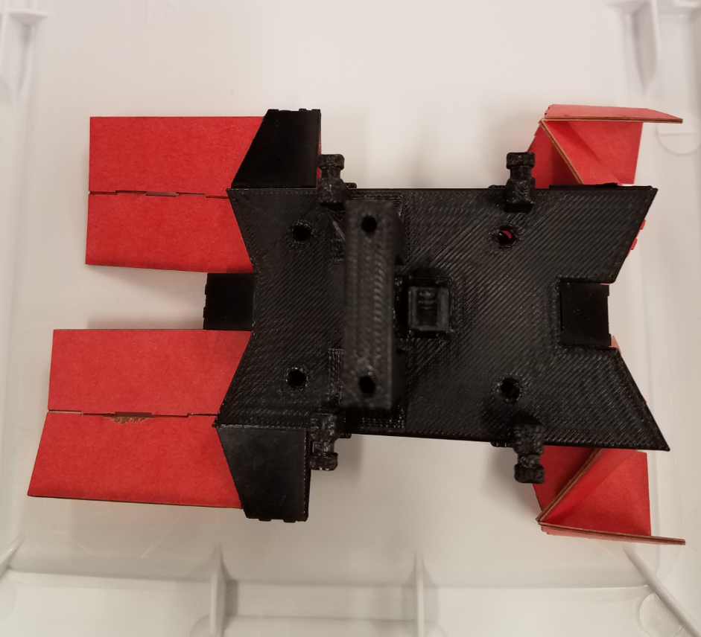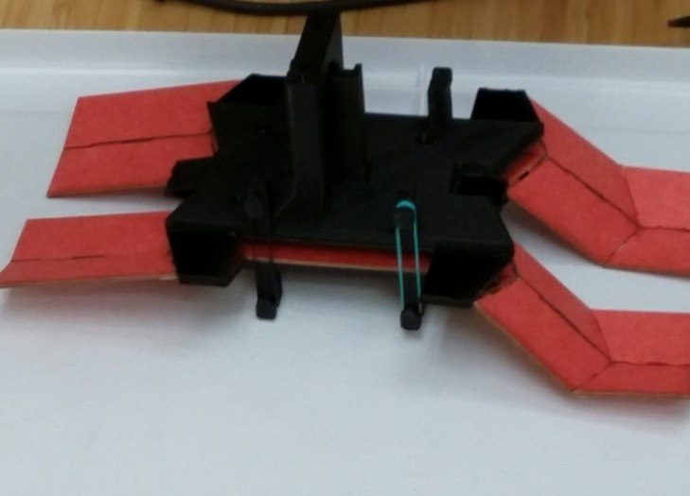

The fourth prototype addressed the concern for both of the previous two issues in the third prototype. Using a cam with an increasing radius we can translate the rotational motion into a linear motion. The sudden decrease in radius will allow for the quick disconnect to deliver the fast acting force from the springs. Secondly, by creating extra links at the front and rear of the mechanism we create a sarrus mechanism which constrains the movement of the top and bottom plate to stay aligned with one another. This design appears to be functional but needs to be refined with the leg lengths and joint angles of the legs as well as reinforcement of the hinges to be as rigid as possible. The modeled motion was only achievable by inverting the leg position to move from 90, 180 motion to 0 to 90 degrees of motion

## F. Prototype V

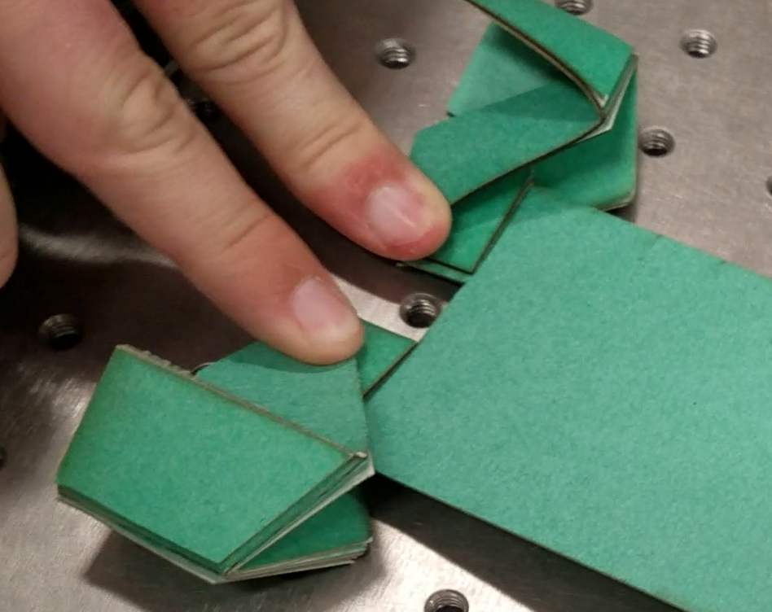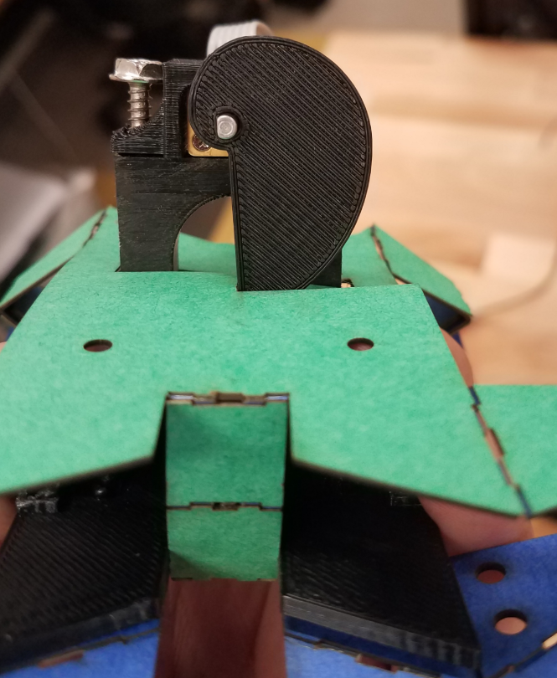

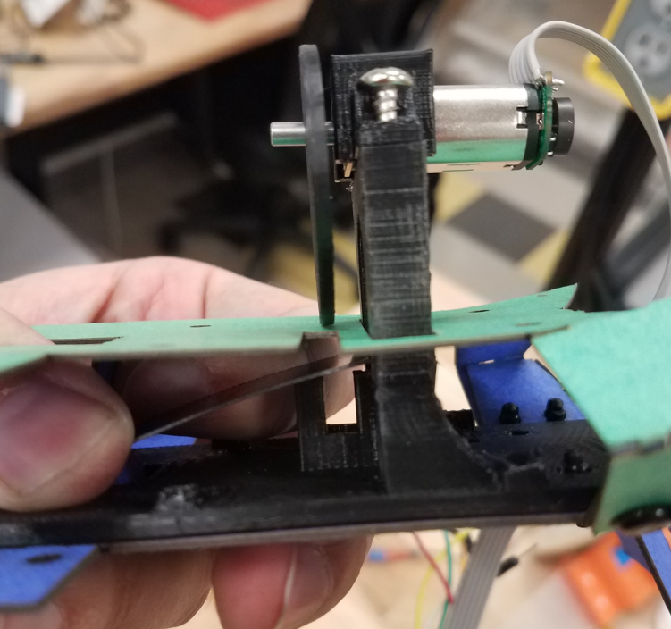

The next prototype switched from a tension spring to compression springs. This utilizes the closed to open motion modeled in the python simulation. Issues with dimensions mountings not being zero width cause interference. The Cam compresses the spring between the two laminate layers moving the rear leg joints from 90 degrees to a closed 0 degrees. Once the cam slips off the stored energy of the compression springs is released rapidly moving the folded leg angel from 0 to 90 degrees where the cam is reset.

## G. Prototype VI

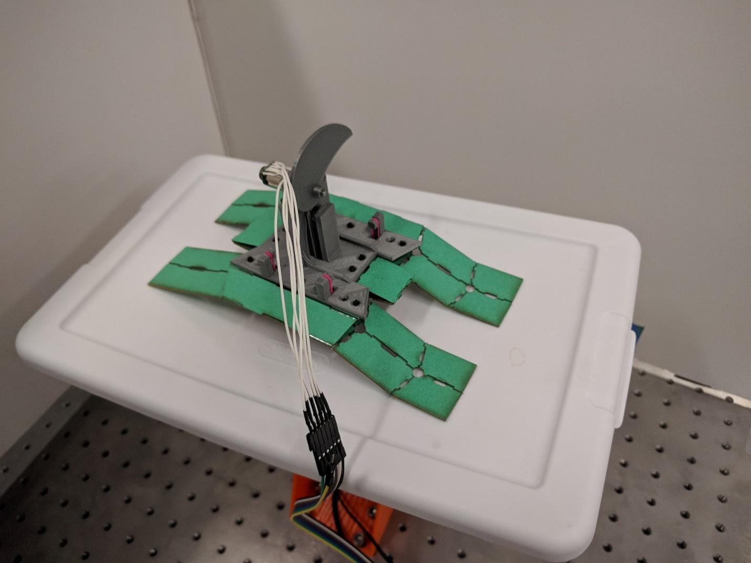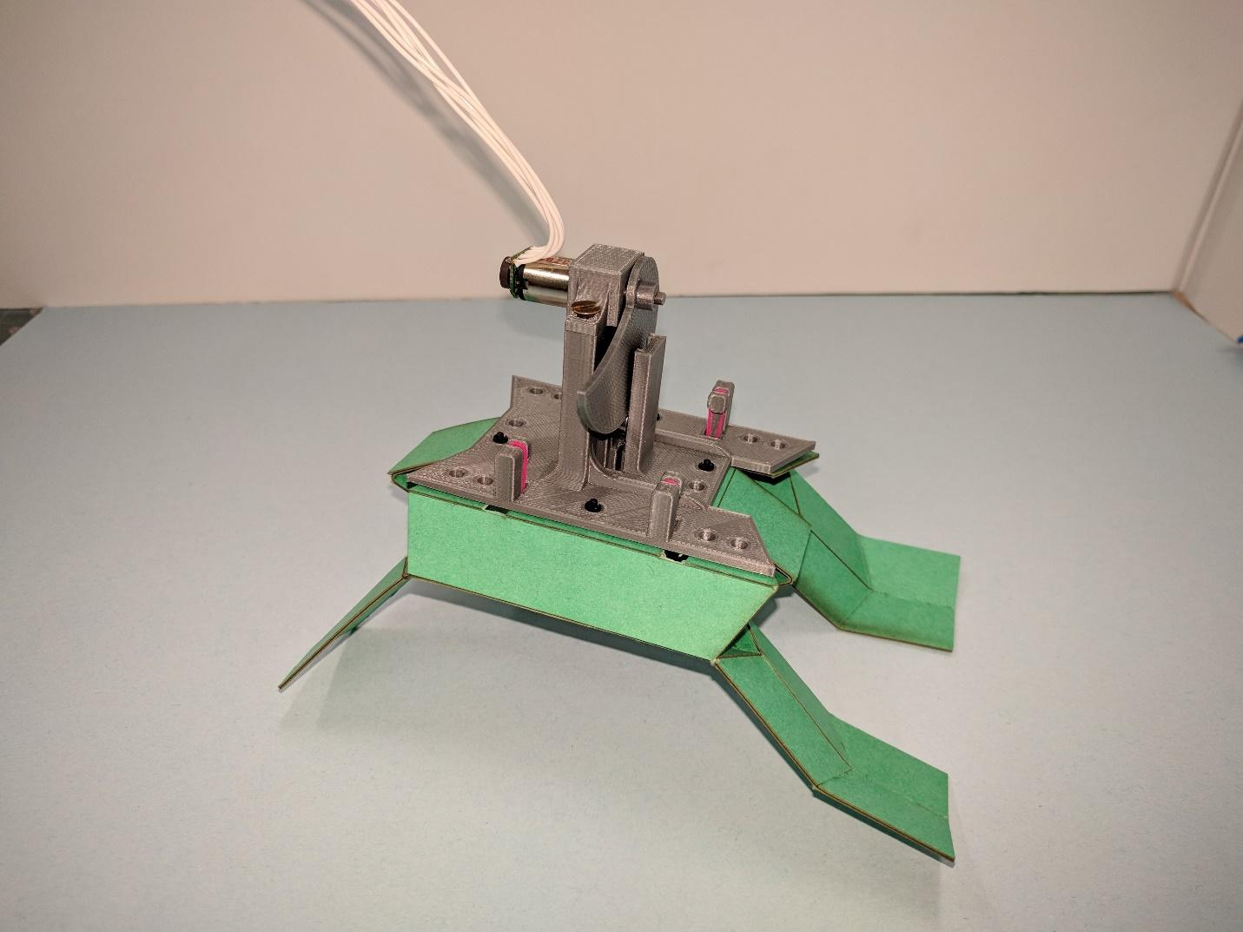

The prototype weighed 178 grams with all the components onboard. Tests were performed using this prototype and the results were studied. The hinges on this prototype are 2mm wide castellated. The rubber bands were weaved into the 3D print to provide a wider Sarrus linkage on the sides. This kept the robot body stable.